PAPER-BASED AUTOMATED MCQ SYSTEM

Mini Project report submitted
in partial fulfilment of the requirement for the degree of

Bachelor of Technology

By
Chandan Chutia (23/151)
Hrisikesh Das (23/153)
Kundil Kashyap Gogoi (23/157)

Under the guidance of
Dr. Gunajit Kalita
HOD, Department of CSE


DEPARTMENT OF COMPUTER SCIENCE & ENGINEERING

ASSAM ENGINEERING COLLEGE
JALUKBARI- 781013, GUWAHATI

11 June, 2026

DECLARATION

I declare that this written submission represents my ideas in my own words and where others' ideas or words have been included, I have adequately cited and referenced the original sources. I also declare that I have adhered to all principles of academic honesty and integrity and have not misrepresented or fabricated or falsified any idea/data/fact/source in my submission. I understand that any violation of the above will be cause for disciplinary action by the Institute and can also evoke penal action from the sources which have thus not been properly cited or from whom proper permission has not been taken when needed.

(Signature) (Name of the student)
(Roll No.) Date:

ACKNOWLEDGEMENT

We hereby declare that the project report entitled “Paper-Based Automated MCQ System”, submitted in partial fulfillment of the requirements for the award of the degree of Bachelor of Technology in Computer Science and Engineering at Assam Engineering College, Guwahati, is a record of the original work carried out by us under the guidance and supervision of Dr. Gunajit Kalita, Department of Computer Science and Engineering, Assam Engineering College.

First and foremost, we extend our heartfelt gratitude to Dr. Gunajit Kalita sir, Head of the Department of Computer Science and Engineering, for providing the necessary administrative support, resources, and an encouraging environment that allowed us to pursue this innovative project.

​We are immensely indebted to our project supervisor, Dr. Gunajit Kalita, for his valuable guidance, encouragement, and continuous support. for their constant guidance, constructive feedback, and immense patience. Their deep understanding of automation and image processing technologies was crucial in helping me overcome technical roadblocks during the system's development. We would also like to express our sincere appreciation closely monitoring the progress of this project, offering valuable insights during internal evaluations, and ensuring that the project met all institutional benchmarks. We are highly grateful to all the faculty members of all faculty members of the Department of Computer Science and Engineering for their direct and indirect support, useful suggestions, and academic insights that enriched my understanding during the project tenure.
​

CHANDAN CHUTIA (23/151)
HRISIKESH DAS (23/153)
KUNDIL KASHYAP GOGOI (23/157)

ABSTRACT

​In the contemporary educational landscape, the rapid expansion of student enrollment has placed an unprecedented burden on educators regarding assessment management. Multiple Choice Question (MCQ) examinations have emerged as a cornerstone for evaluating student performance efficiently due to their objective nature and broad syllabus coverage. However, traditional manual grading of paper-based MCQs is notoriously time-consuming, tedious, and highly susceptible to human error, which ultimately delays crucial academic feedback. This project addresses these challenges by developing a Paper-Based Automated MCQ System. The primary objective of this work is to design a cost-effective, highly accurate, and accessible solution that automates the evaluation of physical bubble sheets, thereby bridging the gap between traditional paper assessments and modern digital efficiency.
The methodology adopted in this project focuses on leveraging computer vision and digital image processing techniques to automate the grading workflow. The system begins by capturing images of completed MCQ answer sheets using standard scanning devices or high-resolution mobile cameras. These raw images undergo preprocessing, including grayscale conversion, noise reduction, and perspective correction, to align the document uniformly. An advanced contours-detection algorithm is then deployed to isolate the specific region of interest (ROI) containing the bubble responses. By analyzing the pixel density and intensity variations within each bubble, the system accurately detects the marked options, compares them against a pre-loaded answer key matrix, and computes the final scores instantaneously.
The implementation of the system yielded highly promising results. The system successfully managed variations in paper orientation and minor alignment skews without compromising data integrity. Furthermore, the evaluation time per optical sheet was drastically reduced to less than two seconds, showcasing a massive efficiency leap over manual grading methods. The significance of these results lies in the system's ability to provide immediate, error-free academic feedback, allowing educators to identify learning gaps promptly and redirect their valuable time from administrative grading toward active student mentorship.
In conclusion, the Paper-Based Automated MCQ System successfully delivers a robust, scalable, and user-friendly alternative to expensive, proprietary Optical Mark Recognition (OMR) hardware. By utilizing ubiquitous computing devices and sophisticated image processing algorithms, the project democratizes automated grading for institutions with limited budgets. The final system achieves an optimal balance between accuracy, processing speed, and cost-effectiveness, proving that digital automation can be seamlessly integrated into traditional paper-based testing environments. The software tools and packages used to develop this system include Python,OpenCV,NumPy,IMutils
Contents
ASSAM ENGINEERING COLLEGE 1
DECLARATION i
ACKNOWLEDGEMENT 2
ABSTRACT 3
CHAPTER 1:INTRODUCTION 1
1.1 Introduction to the chapter 1
1.4 Motivation to Do the Project Work 2
1.5 Objective of the Work 2
1.6 Target Specifications 3
CHAPTER 2: LITERATURE REVIEW 4
2.1 Introduction 4
2.2 Introduction to the Project 4
2.3 Literature Review 5
2.4 Summarized Outcome of the Literature Review 7
2.5 Theoretical Discussion 8
2.6 General Analysis 8
CHAPTER 3:METHODOLOGY 9
3.1 Introduction 9
3.2 Methodology 9
CHAPTER 4:RESULT ANALYSIS 14
4.1 Introduction 14
4.2 Result Analysis 14
4.3 Significance of the Result Obtained 17
CHAPTER 5: CONCLUSION AND FUTURE SCOPE OF WORK 18
5.1 Brief Summary of the Work 18
5.2 Conclusions 18
REFERENCE 21
ANNEXURE 22

CHAPTER 1:INTRODUCTION

1.1 Introduction to the chapter
This chapter establishes the foundational framework for the Paper-Based Automated MCQ System. It begins with a broad overview of the educational assessment domain, followed by an analysis of the current technological landscape and the core motivations driving this research. Furthermore, this chapter highlights the limitations of existing methodologies, defines the primary and secondary objectives of the project, outlines the target technical specifications, and concludes with a structural roadmap detailing the organization of the entire project report.

​1.2 Introduction to the Area of Work
Educational assessment is a critical component of the academic ecosystem, serving as the primary mechanism to gauge student understanding, evaluate instructional effectiveness, and maintain academic standards. Among various assessment methodologies, Multiple Choice Question (MCQ) examinations have become globally ubiquitous. MCQs offer an objective, standardized, and comprehensive means of testing a wide spectrum of a syllabus within a limited timeframe. The core area of this work lies at the intersection of educational technology and computer vision, specifically focusing on automating the evaluation of physical, paper-based assessments to reduce human intervention and streamline administrative workflows.

​1.3 Brief Present-Day Scenario
In the current educational landscape, institutions are experiencing unprecedented growth in student enrollment. While digital, computer-based testing (CBT) has gained traction, paper-based examinations remain irreplaceable in many scenarios due to digital infrastructure deficits, budget constraints, or the logistical challenges of securing large-scale computer labs. Consequently, educators are forced to manually grade thousands of physical bubble sheets. This present-day reliance on manual grading creates a massive bottleneck, consuming valuable teaching hours, causing significant delays in feedback, and introducing human fatigue that frequently leads to grading inaccuracies.

1.4 Motivation to Do the Project Work
The drive to develop this system stems from a critical need to modernize traditional grading workflows without requiring expensive infrastructural overhauls.
- Shortcomings in the Previous Work / Reference Papers:
Prior automated grading systems heavily relied on dedicated Optical Mark Recognition (OMR) hardware scanners. These machines are expensive, high-maintenance, and require specialized, costly pre-printed paper sheets. Early software-based attempts often lacked robustness, failing to process images that had minor skews, variations in ambient lighting, or wrinkles on the paper.
- Brief Importance of the Work in the Present Context:
In the modern academic environment, rapid feedback is crucial for effective learning interventions. This project provides a bridge between traditional paper tests and digital speed, allowing resource-constrained institutions to digitize their grading workflow instantly using existing, everyday hardware.
- Uniqueness of the Methodology to be Adopted:
Unlike rigid, traditional OMR systems, the methodology adopted in this project utilizes advanced computer vision techniques (such as contour filtering and dynamic pixel-density analysis via OpenCV). This allows the system to process images captured from low-cost mobile phone cameras or standard office scanners, featuring built-in algorithmic resilience against geometric distortions and lighting fluctuations.
- ​Significance of the Possible End Result:
The successful implementation of this project will result in a highly accessible, software-driven solution that democratizes automated grading. It eliminates human error, cuts down grading time from hours to seconds per batch, and frees educators to focus on active teaching rather than administrative paperwork.
​

1.5 Objective of the Work
​The definitive goals of this project are structured as follows:
- To design and develop a robust, software-based Automated MCQ Evaluation System that accurately detects and grades handwritten marks on paper bubble sheets using computer vision technique.
- To implement image preprocessing algorithms that correct page rotation, tilting, and lighting variations.

- To generate instantaneous digital scorecards and data logs for streamlined academic record-keeping.

1.6 Target Specifications
To ensure that the proposed Paper-Based Automated MCQ System provides an efficient, reliable, and practical solution for educational institutions, the following target specifications have been established:

Parameter | Target Specification
Programming Language | Python 3.x
Web Framework | Flask
Database | SQLite
Image Processing Library | OpenCV 4.x
PDF Generation Tool | ReportLab
Frontend Technologies | HTML5, CSS3, JavaScript
OMR Sheet Generation | Automatic PDF-based OMR Sheet Creation
Result Storage | Secure Database Storage
Maximum Questions Supported | Up to 100 Questions per OMR Sheet

CHAPTER 2: LITERATURE REVIEW

2.1 Introduction
This chapter presents a detailed review of the concepts, technologies, and existing research related to the development of the Paper-Based Automated MCQ Evaluation System using Optical Mark Recognition (OMR) and OpenCV. The chapter discusses the need for automated examination evaluation systems, recent developments in OMR technology, and the role of image processing in educational applications. A review of existing literature is also presented to identify the limitations of current systems and establish the motivation for the proposed solution. Furthermore, the theoretical concepts and technologies used in the project are discussed to provide a strong foundation for understanding the system design and implementation.

2.2 Introduction to the Project
The evaluation of Multiple Choice Question (MCQ) examinations is an essential activity in educational institutions. Traditionally, answer sheets are evaluated manually by teachers, which requires significant time and effort, especially when dealing with a large number of students. Manual evaluation is also prone to human errors, inconsistencies, and delays in result publication.
Optical Mark Recognition (OMR) technology has been widely used to automate the evaluation of MCQ examinations. Conventional OMR systems rely on specialized hardware scanners that can accurately detect marked responses on answer sheets. However, such systems are often expensive and may not be affordable for small educational institutions and organizations.
The Paper-Based Automated MCQ Evaluation System using OMR and OpenCV aims to provide a cost-effective and efficient alternative to traditional OMR systems. The proposed system uses image processing techniques to analyze scanned OMR sheets and automatically evaluate student responses. Teachers can create examinations, define answer keys, and generate customized OMR sheets through a web-based interface. Students complete the examination using the generated OMR sheets, which are later scanned and uploaded to the system for evaluation.
The system automatically detects marked answers, compares them with the stored answer key, calculates scores, and generates results. The integration of OpenCV and web technologies enables fast, reliable, and accurate evaluation without requiring specialized OMR hardware.

2.3 Literature Review
2.3.1 Present State and Recent Developments:
The field of automated examination evaluation has experienced significant advancements in recent years due to rapid developments in computer vision, image processing, artificial intelligence, and web technologies. Educational institutions are increasingly adopting digital solutions to improve examination management, reduce administrative workload, and enhance evaluation accuracy.
Traditional Optical Mark Recognition (OMR) systems depend on specialized hardware scanners and pre-designed answer sheets for detecting marked responses. Although these systems offer high accuracy, their deployment and maintenance costs are often prohibitive for small and medium-sized educational institutions. As a result, researchers have focused on developing software-based OMR systems that utilize standard scanners, webcams, and smartphone cameras for answer sheet processing.
Recent developments in this area include the application of computer vision algorithms for bubble detection, perspective correction, and answer recognition. Modern OMR systems are capable of handling variations in image quality, lighting conditions, and sheet alignment, thereby improving reliability and usability.
The integration of mobile technologies has further enhanced accessibility by allowing users to capture and process OMR sheets using smartphone cameras. Additionally, cloud-based evaluation platforms have emerged as a practical solution for centralized examination management, enabling remote access, large-scale deployment, and efficient result processing.

2.3.2 Background Theory
1. Optical Mark Recognition (OMR):
Optical Mark Recognition (OMR) is a technology used to detect human-marked responses on specially designed forms and answer sheets. The technique identifies filled bubbles or checkboxes by analyzing image characteristics such as pixel intensity, shape, area, and contrast. OMR technology is widely used to automate data collection and evaluation processes while minimizing manual effort and human error.
The major applications of OMR include examination evaluation, survey processing, voting systems, attendance management, and data collection forms.

2. Digital Image Processing:
Digital Image Processing refers to the use of computational techniques to analyze, enhance, and extract meaningful information from digital images. In the proposed system, image processing techniques are used to detect answer bubbles and identify marked responses accurately.

Several image processing operations are employed during evaluation. Grayscale conversion simplifies image analysis by reducing color information. Noise reduction techniques such as Gaussian blurring improve image quality by removing unwanted disturbances. Thresholding converts grayscale images into binary images, enabling easier separation of foreground objects from the background. Contour detection is used to identify the boundaries of answer bubbles and the OMR sheet. Perspective correction removes distortions caused by improper scanning angles, while bubble detection determines whether an answer option has been selected by analyzing the pixel density within each bubble.

3. Thresholding: Thresholding converts the grayscale image into a binary image by separating foreground objects from the background.
Contour Detection: Contours represent the boundaries of objects within an image. Contour detection is used to identify answer bubbles and sheet boundaries.
Perspective Correction: Perspective transformation corrects image distortions caused by improper scanning angle
Bubble Detection: Bubble detection determines whether a particular answer option has been marked by analyzing the pixel density within each bubble.

4. OpenCV:
OpenCV (Open Source Computer Vision Library) is a widely used open-source library designed for computer vision and image processing applications. It provides efficient algorithms for image enhancement, contour analysis, object detection, feature extraction, and pattern recognition.
In the proposed system, OpenCV serves as the primary image processing framework and is responsible for image preprocessing, contour detection, perspective transformation, bubble extraction, and answer recognition.
5. Database Management Systems:
Database Management Systems (DBMS) are used to store, organize, and manage examination-related information efficiently. In the proposed system, the database stores examination details, answer keys, student information, and evaluation results.
A DBMS ensures data consistency, secure storage, efficient retrieval, and reliable management of examination records.

2.3.3 Literature Survey
A detailed literature survey was conducted to study existing OMR-based examination evaluation systems and identify their strengths and limitations.

Study 1: Automated Optical Mark Recognition System Using Image Processing Techniques
This study presented an automated OMR system based on image processing algorithms for recognizing marked answers from examination sheets. The system utilized thresholding and contour detection techniques to identify filled bubbles and evaluate answer sheets automatically. The proposed approach achieved high recognition accuracy and significantly reduced manual effort and evaluation time. However, the system was highly dependent on predefined answer sheet templates, limiting its flexibility.

Study 2: Design and Development of an Automated OMR Evaluation System
This research focused on developing a computer-based OMR evaluation system capable of automatically processing answer sheets and generating examination results. The system demonstrated considerable improvements in efficiency by automating score calculation and reducing human intervention. Despite its effectiveness, the system provided limited support for web-based examination management and result analysis.

Study 3: MCQ Assessment Using Computer Vision and Image Processing
This study proposed an OpenCV-based evaluation system for automatic recognition of marked responses in MCQ examinations. The system employed computer vision techniques to detect answer bubbles and calculate scores accurately. The results showed improved accuracy, reduced evaluation errors, and cost-effective implementation. However, the system lacked integrated examination management features and was not designed for large-scale deployment.

2.4 Summarized Outcome of the Literature Review
The literature review reveals that existing OMR systems provide reliable answer recognition and evaluation capabilities. However, many solutions rely on specialized hardware, fixed answer sheet templates, or limited management functionalities. Some systems focus primarily on image processing without offering complete examination management support.
The proposed system addresses these limitations by integrating OMR processing, examination management, answer key management, result generation, and database storage within a single web-based platform. The use of OpenCV eliminates the need for expensive OMR hardware, making the solution more accessible and cost-effective.

2.5 Theoretical Discussion
The proposed system combines concepts from Optical Mark Recognition, Digital Image Processing, Computer Vision, Database Management, and Web Application Development.
The evaluation process begins with image acquisition. A scanned OMR sheet is uploaded to the system and converted into a grayscale image. Noise reduction techniques improve image quality before thresholding separates the foreground from the background.

Contour detection identifies the boundaries of answer bubbles and the answer sheet. Perspective correction ensures that distorted images are properly aligned before analysis. Bubble extraction algorithms then identify marked responses by measuring pixel density inside each bubble region.
The recognized responses are compared against the answer key stored in the database. The evaluation engine calculates the final score and generates results automatically. These results are stored and displayed through dedicated dashboards. The integration of image processing and web technologies creates a complete automated evaluation platform capable of handling examination management and result generation efficiently.

2.6 General Analysis
The analysis of existing literature and technologies indicates that image-processing-based OMR systems provide an effective alternative to traditional evaluation methods. The increasing availability of high-quality scanners, cameras, and open-source libraries has made automated examination evaluation more accessible than ever before. The proposed system combines the strengths of modern image processing techniques and web application technologies to deliver a comprehensive examination management solution. Compared with traditional OMR systems, the proposed approach offers lower implementation costs, greater flexibility, easier deployment, and improved accessibility. The overall analysis confirms that the proposed Paper-Based Automated MCQ Evaluation System using OMR and OpenCV is technically feasible, economically viable, and suitable for practical deployment in educational institutions.

CHAPTER 3:METHODOLOGY

3.1 Introduction
This chapter describes the methodology adopted for the design and development of the Paper-Based Automated MCQ Evaluation System using OMR and OpenCV. It explains the complete workflow of the system, including OMR sheet generation, image processing, answer recognition, and result generation. The chapter also discusses the assumptions made during implementation, system architecture, component specifications, justification for component selection, and the software tools used in the development process.

3.2 Methodology
3.2.1 Detailed Methodology
The proposed system automates the evaluation of multiple-choice examinations using Optical Mark Recognition (OMR) and image processing techniques. The methodology consists of the following stages:
Step 1: Teacher Authentication
The teacher logs into the system using valid credentials. Authentication ensures secure access to examination management features.
Step 2: Exam Creation
The teacher creates an examination by entering details such as subject name, examination title, total questions, and marks distribution.
Step 3: Answer Key Entry
The correct answers for all questions are entered and stored in the database. This answer key is later used for automatic evaluation.
Step 4: OMR Sheet Generation
The system generates a customized OMR answer sheet in PDF format using ReportLab. The generated sheet contains unique question numbers and answer bubbles.
Step 5: Student Response Collection
Students fill the OMR sheet manually and submit the scanned copy in JPG, PNG, or PDF format.
Step 6: Image Processing
The uploaded OMR sheet is processed using OpenCV. Various preprocessing techniques are applied to improve image quality and accuracy.
Step 7: Bubble Detection
The system identifies all answer bubbles using contour detection and image segmentation techniques.

Step 8: Answer Recognition
Marked bubbles are detected by analyzing pixel intensity and fill percentage within each bubble.
Step 9: Evaluation Process
Detected answers are compared with the stored answer key to determine correct and incorrect responses.
Step 10: Score Calculation
The evaluation engine calculates the total score according to the examination marking scheme
Step 11: Result Storage and Display
Results are stored in the SQLite database and displayed through teacher and student dashboards.

3.2.2 Assumptions Made
- OMR sheets are scanned with adequate resolution and clarity.
- Students mark answers using dark ink or pencil.
- Each question contains only one correct answer.
- The answer key entered by the teacher is accurate.
- Uploaded files are in supported formats such as JPG, PNG, or PDF.
- The OMR sheet layout remains unchanged during evaluation.
- Adequate lighting conditions are maintained while scanning.

3.2.3 System Architecture
The architecture of the proposed Paper-Based Automated MCQ System consists of several interconnected modules that work together to automate the examination evaluation process. The system begins with the teacher creating an examination and entering the answer key through the web portal. The OMR Sheet Generator then creates customized answer sheets in PDF format.

After students complete the examination, the scanned OMR sheets are uploaded to the system. The Image Processing Module uses OpenCV to preprocess the image, detect answer bubbles, and identify marked responses. The Evaluation Engine compares the detected responses with the stored answer key and calculates the final score. The generated results are stored in the SQLite database and displayed through the dashboard interface.

The overall architecture of the system is illustrated in Figure 3.1.

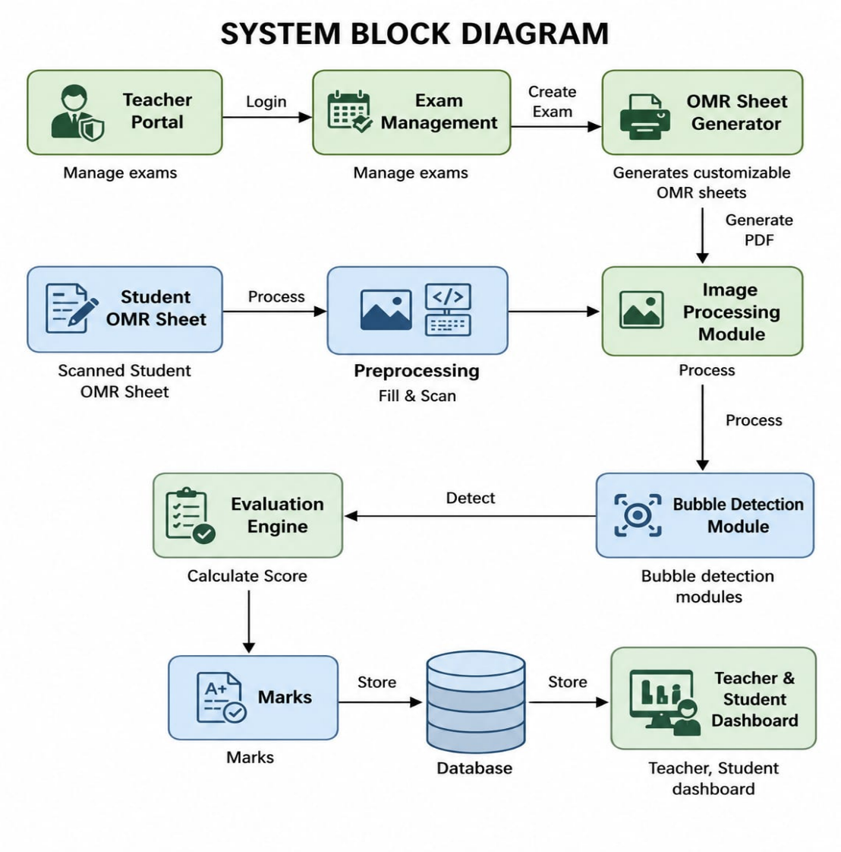

Fig. 3.1

Description of Block Diagram-
Teacher Portal: Allows teachers to manage examinations and answer keys.
Exam Management: Handles creation and modification of examinations.
OMR Sheet Generator: Generates customized OMR answer sheets.
Image Processing Module: Processes uploaded answer sheets using OpenCV.
Bubble Detection Module: Detects marked answer bubbles.
Evaluation Engine: Compares detected answers with the answer key.
Database: Stores examination data and results.
Dashboard: Displays examination results to users.

3.2.4 Component Specifications

Table 3.1: Component Specifications

Component | Specification
Programming Language | Python 3.x
Framework | Flask
Database | SQLite
Image Processing Library | OpenCV 4.x
PDF Generation Tool | ReportLab
Frontend Technologies | HTML5, CSS3, JavaScript
Version Control | Git and GitHub
Operating System
  Windows/Linux
Input Formats | JPG, PNG, PDF
Output | Evaluation Results and Reports

Table 3.2: Tools Used

Tool | Purpose
Python | Backend development
Flask
  Web application framework
OpenCV | Image processing and OMR detection
SQLite | Database management
ReportLab | PDF generation
HTML/CSS/JavaScript | Frontend development
Visual Studio Code | Code development and debugging
Git & GitHub | Version control

3.2.4 Justification for Component Selection
1. Python
Python was selected because it is easy to learn, highly readable, and provides extensive upport for web development and image processing.
2. Flask
Flask was chosen as it is lightweight, flexible, and integrates well with Python-based applications.
3. OpenCV
OpenCV offers powerful image processing and computer vision capabilities necessary for bubble detection and answer recognition.
4. SQLite
SQLite is lightweight, requires no separate server, and efficiently manages examination data.
5. ReportLab
ReportLab was selected for generating customized OMR sheets in PDF format. It provides powerful tools for creating structured documents, formatting layouts, and dynamically generating printable answer sheets required for examinations.
6. HTML, CSS, and JavaScript
hese technologies provide a responsive and user-friendly interface for both teachers and
students.
7. Git and GitHub
Git and GitHub help in version control, code management, and project collaboration.

CHAPTER 4:RESULT ANALYSIS

4.1 Introduction
This chapter presents the results obtained from the implementation and testing of the Paper-Based Automated MCQ System using OMR and OpenCV. The developed system was evaluated to verify its ability to generate OMR sheets, process scanned answer sheets, detect marked responses accurately, calculate scores automatically, and store results in the database. The performance of the system is analyzed through functional testing, result generation, and graphical representation of the obtained outcomes. The significance of the results is also discussed to demonstrate the effectiveness and practical applicability of the proposed solution.

4.2 Result Analysis
Developed system was tested using multiple OMR answer sheets containing different answer patterns. The system successfully processed uploaded images, detected marked bubbles, compared responses with the stored answer key, and generated results automatically.

4.2.1 Module-wise Testing Results

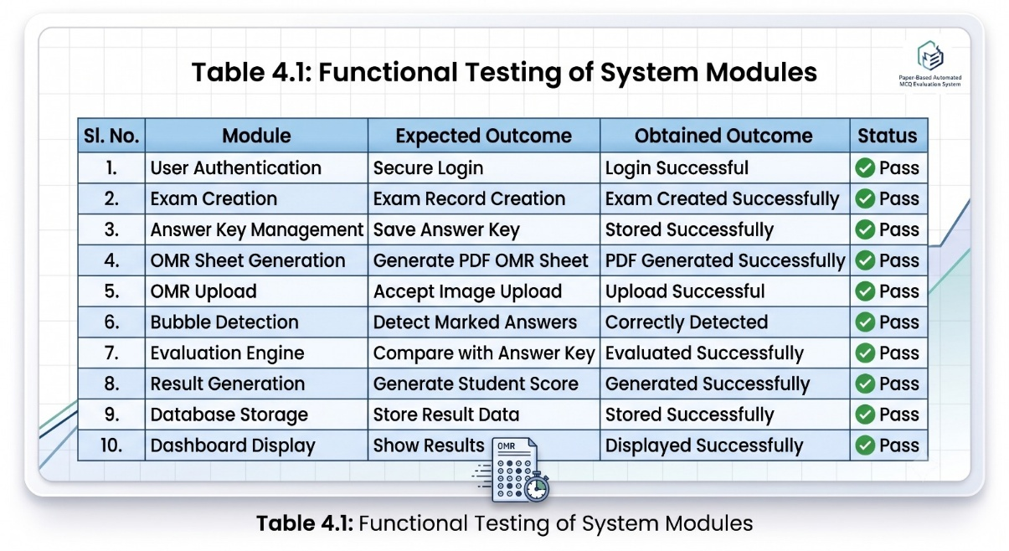

Analysis of Table 4.1
The results indicate that all major modules of the system performed according to the expected functionality. No critical failures were observed during testing. The integration between the web application, database, and image processing modules was successful, demonstrating the reliability of the proposed system.

4.2.2 Sample Student Evaluation Results

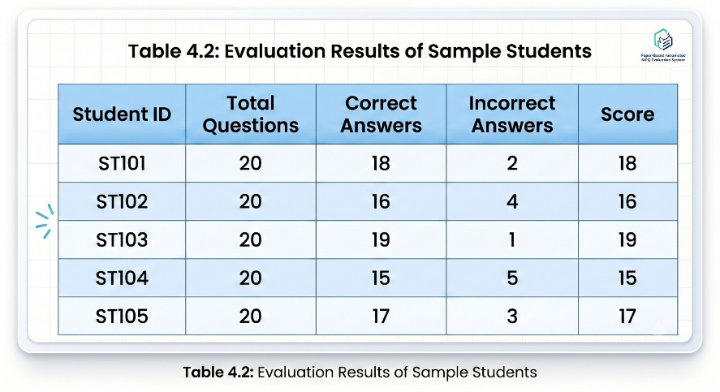

Analysis of Table 4.2
The evaluation engine successfully identified student responses and compared them with the answer key. The calculated scores matched the expected results, confirming the correctness of the answer recognition and scoring mechanism. The generated results were automatically stored in the database and displayed through the student dashboard.

4.2.3 Processing Performance Analysis

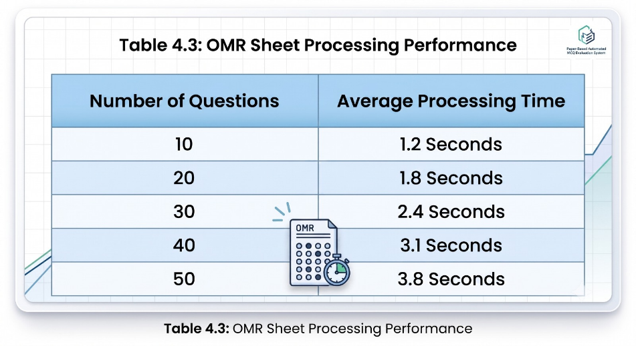

Analysis of Table 4.3
The processing time increased gradually with the number of questions, but remained within acceptable limits for real-time evaluation. The results demonstrate that the system can efficiently handle OMR sheets containing a large number of questions while maintaining fast evaluation speed.

4.2.4 Graphical Representation of Results

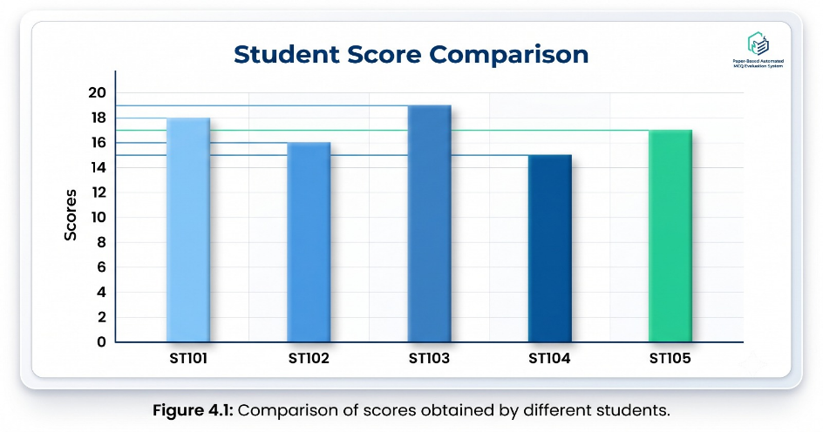

Analysis of Figure 4.1
The graph illustrates the scores obtained by different students after automatic evaluation. The variation in scores reflects differences in student performance rather than any processing error. The system accurately calculated marks according to the predefined answer key.

4.2.5 Screenshot-Based Result Analysis
The successful implementation of the system can also be demonstrated through screenshots obtained during testing.
Screenshot 1: Teacher Dashboard
The teacher dashboard provides facilities for creating examinations, entering answer keys, generating OMR sheets, and viewing evaluation results.
Screenshot 2: Generated OMR Sheet
The system successfully generated customized OMR sheets in PDF format. Each sheet contained structured question numbers and answer bubbles for examination purposes.
Screenshot 3: OMR Sheet Upload Interface
The upload module accepted scanned OMR sheets in supported formats and transferred them to the image processing module for evaluation.
Screenshot 4: Result Dashboard
result dashboard displayed student scores, examination details, and evaluation statistics in a user-friendly format.

4.3 Significance of the Result Obtained
The obtained results demonstrate that the proposed OMR-based MCQ evaluation system successfully automates the entire assessment process. The use of OpenCV for image processing enables accurate bubble detection and answer recognition, reducing the possibility of human error associated with manual evaluation.
The generated results confirm that the system can:
- Automatically evaluate MCQ examinations.
- Generate accurate scores within a short period of time.
- Reduce manual workload for teachers.
- Provide secure storage of examination records.
- Improve transparency and reliability in the evaluation process.
- Support quick result publication through web dashboards.
The successful implementation of all modules indicates that the proposed solution is practical for educational institutions, coaching centers, and examination authorities requiring efficient MCQ evaluation systems.

4.4 Summary
The developed system successfully performed all intended functionalities, including OMR sheet generation, image processing, answer recognition, automatic evaluation, and result management. The obtained results validate the effectiveness, accuracy, and reliability of the proposed Paper-Based Automated MCQ Evaluation System using OMR and OpenCV. The system significantly reduces evaluation time and provides a cost-effective solution for automated examination assessment.

CHAPTER 5: CONCLUSION AND FUTURE SCOPE OF WORK

5.1 Brief Summary of the Work
5.1.1 Problem Statement and Objective
The traditional process of evaluating Multiple Choice Question (MCQ) examinations is time-consuming, labor-intensive, and prone to human errors. Educational institutions often spend significant time checking answer sheets and preparing results, especially when dealing with a large number of students. Manual evaluation may also lead to inconsistencies and inaccuracies in scoring.
The primary objective of this project was to develop a **Paper-Based Automated MCQ Evaluation System using Optical Mark Recognition (OMR) and OpenCV** that can automate the entire evaluation process. The system aims to generate customized OMR answer sheets, detect marked responses from scanned answer sheets, evaluate answers against predefined answer keys, calculate scores automatically, and generate results efficiently. The project also seeks to reduce evaluation time, improve accuracy, and provide a user-friendly platform for both teachers and students.

5.1.2 Work Methodology Adopted
The proposed system was developed using Python, Flask, OpenCV, SQLite, and ReportLab. Initially, teachers create examinations and enter the corresponding answer keys through a web-based interface. The system then generates customized OMR answer sheets in PDF format.
After students complete the examination, the filled OMR sheets are scanned and uploaded to the system. OpenCV-based image processing techniques such as grayscale conversion, Gaussian blurring, thresholding, contour detection, perspective correction, and bubble extraction are applied to identify marked responses accurately. The detected answers are compared with the stored answer key, and scores are calculated automatically. The final results are stored in the database and displayed through dedicated dashboards for teachers and students.
This methodology ensures efficient, accurate, and reliable evaluation while minimizing manual effort and reducing the possibility of human error.

5.2 Conclusions
5.2.1 General Conclusions
The Paper-Based Automated MCQ Evaluation System using OMR and OpenCV was successfully designed, developed, and tested. The system achieved all the objectives defined at the beginning of the project and demonstrated the practical implementation of image processing techniques in educational assessment.

The developed application successfully generates OMR sheets, processes scanned answer sheets, detects marked bubbles, evaluates responses, calculates scores, and stores examination results automatically. The integration of OpenCV with a web-based platform enabled accurate answer recognition and seamless result generation.
The system provides an efficient alternative to traditional manual evaluation methods and significantly reduces the workload of teachers and examination authorities. Furthermore, the user-friendly interface allows easy interaction with the system without requiring advanced technical knowledge.

5.2.2 Significance of the Results Obtained
The results obtained from the implementation and testing of the system demonstrate its effectiveness and reliability in automating MCQ evaluation. The significance of the developed system can be summarized as follows:
- The system successfully automates the complete MCQ evaluation process.
- Accurate bubble detection minimizes errors during answer recognition.
- Automatic score calculation reduces evaluation time significantly.
- The system eliminates most manual effort involved in result preparation.
- Examination records and results are securely stored in a database.
- Instant result generation improves efficiency and transparency.
- The web-based platform provides convenient access for both teachers and students.
- The system can be implemented in schools, colleges, coaching institutes, and examination centers.
The successful operation of all modules confirms that the proposed solution is practical, reliable, and suitable for real-world educational environments.

5.3 Future Scope of Work
Although the developed system successfully meets its intended objectives, several enhancements can be incorporated in future versions to improve functionality, scalability, and performance.
Mobile Application Integration:
A dedicated Android or iOS application can be developed to allow teachers and students to access the system through mobile devices. Mobile-based scanning can also simplify OMR sheet submission.
2. Real-Time Camera-Based OMR Detection
Future versions may support direct evaluation using a smartphone or webcam without requiring manual scanning and uploading of answer sheets.
3. Cloud-Based Deployment
The system can be migrated to cloud platforms to support large-scale deployments, remote access, centralized data storage, and improved scalability.
4. Advanced Analytics and Reporting
Additional analytical features such as student performance analysis, subject-wise statistics, graphical reports, and examination trends can be incorporated to assist teachers in decision-making.
5. Artificial Intelligence Integration
Machine learning and artificial intelligence techniques can be integrated to improve recognition accuracy and handle partially filled, damaged, or improperly scanned OMR sheets.
6. Multi-Institution Support
The system can be extended to support multiple schools, colleges, or examination centers through a centralized management platform.
7. Enhanced Security Features
Future versions may include role-based access control, encrypted data storage, secure cloud backups, and advanced authentication mechanisms to improve system security.
8. Support for Negative Marking and Advanced Evaluation Rules
Additional examination schemes such as negative marking, weighted questions, sectional evaluation, and customized scoring policies can be incorporated.
9. Integration with Learning Management Systems
The application can be integrated with existing Learning Management Systems (LMS) to streamline examination management and result publication.
10. Large-Scale Examination Support
Future enhancements can optimize processing speed and database performance to support large-scale examinations involving thousands of students simultaneously.
5.4 Final Remark
The Paper-Based Automated MCQ Evaluation System using OMR and OpenCV provides an effective, accurate, and efficient solution for automating MCQ examination assessment. By combining image processing techniques with web technologies, the system reduces evaluation time, minimizes human errors, and improves result management. The successful implementation of this project demonstrates the potential of OMR and computer vision technologies in modern educational assessment systems and provides a strong foundation for future enhancements and large-scale deployment.

REFERENCE

- OpenCV, Open Source Computer Vision Library Documentation, OpenCV Foundation, 2025.
- Flask, Flask Web Framework Documentation, Pallets Projects, 2025.
- SQLite Development Team, SQLite Database Engine Documentation, SQLite Documentation, 2025.
- ReportLab Software Ltd., ReportLab PDF Generation Toolkit Documentation, 2025.
- W3Schools, Python, HTML, CSS, JavaScript and SQL Tutorials, W3Schools Learning Platform.
- GeeksforGeeks, Python Programming and OpenCV Tutorials, GeeksforGeeks Learning Resources.
- YouTube Educational Resources, Tutorials on OpenCV, Flask, and OMR Sheet Processing, Various Educational Technology Channels.
- M. Grinberg, Flask Web Development: Developing Web Applications with Python, 2nd ed., Sebastopol, CA, USA: O'Reilly Media, 2018.
- R. C. Gonzalez and R. E. Woods, Digital Image Processing, 4th ed., New York, NY, USA: Pearson Education, 2018.

ANNEXURE
ANNEXURE A

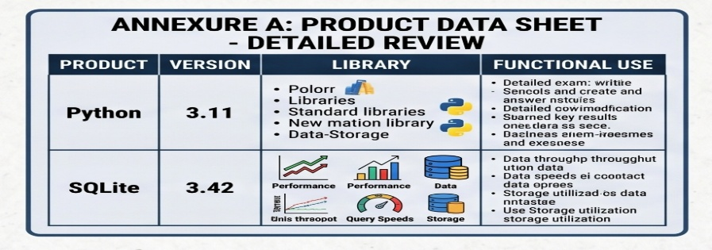

A.1 Python Programming Language
Version Used: Python 3.x
Purpose: Python is used as the primary programming language for implementing backend logic, image processing modules, database connectivity, and evaluation algorithms.
Features:
- Simple and readable syntax
- Extensive library support
- Platform independent
- Easy integration with OpenCV and Flask
A.2 OpenCV Library
Version Used: OpenCV 4.x
Purpose: OpenCV is used for image processing and Optical Mark Recognition (OMR) operations.
Functions Used:
- Image Reading
- Grayscale Conversion
- Thresholding
- Contour Detection
- Perspective Transformation
- Bubble Detection
A.3 Flask Framework
Purpose: Flask is used for developing the web-based application interface and managing communication between users and the database.
Functions:
- User Authentication
- Routing
- Session Management
- Form Handling
A.4 SQLite Database
Purpose: Stores examination details, answer keys, student records, and evaluation results.
Advantages:
- Lightweight
- Serverless
- Easy Integration

ANNEXURE B
B.1 System Architecture Diagram

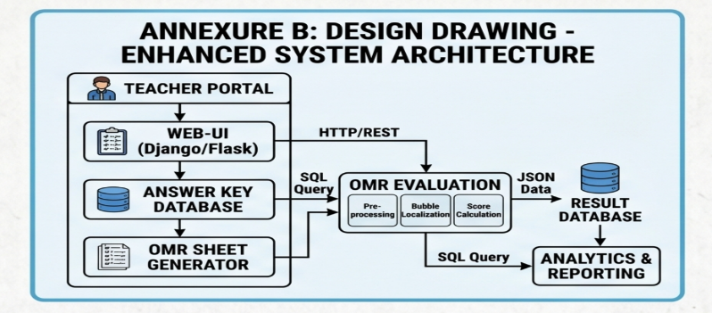

ANNEXURE C
Actors:
- Teacher
- Student
Teacher Functions:
- Login
- Create Exam
- Enter Answer Key
- Generate OMR Sheet
- View Results
Student Functions:
- Login
- View Results
- Download Reports

ANNEXURE D
Algorithms
D.1 OMR Evaluation Algorithm
Algorithm: Automated OMR Evaluation
Step 1: Start
Step 2: Teacher creates examination.
Step 3: Enter answer key.
Step 4: Generate OMR sheet.
Step 5: Student fills OMR sheet.
Step 6: Upload scanned OMR sheet.
Step 7: Convert image to grayscale.
Step 8: Apply Gaussian Blur.
Step 9: Perform thresholding.
Step 10: Detect contours.
Step 11: Correct image perspective.
Step 12: Extract answer bubbles.
Step 13: Detect marked responses.
Step 14: Compare with answer key.
Step 15: Calculate score.
Step 16: Store result in database.
Step 17: Display result dashboard.
Step 18: Stop.

ANNEXURE E
Important Source Code Snippets
E.1 Image Upload Function:
This function is responsible for receiving the uploaded OMR sheet from the user and saving it to the server for further processing.

file = request.files['omr_sheet']
file.save(os.path.join(upload_folder, file.filename))

E.2 Read Uploaded Image
The uploaded image is read using OpenCV and converted into grayscale format to simplify image processing operations.

image = cv2.imread(image_path)
gray = cv2.cvtColor(image, cv2.COLOR_BGR2GRAY)

E.3 Image Thresholding
Thresholding converts the grayscale image into a binary image, making it easier to detect answer bubbles.

thresh = cv2.threshold(
gray,
0,
255,
cv2.THRESH_BINARY_INV | cv2.THRESH_OTSU
)[1]

E.4 Bubble Detection
The following code detects contours that represent answer bubbles on the OMR sheet.
contours, _ = cv2.findContours(thresh.copy(),
cv2.RETR_EXTERNAL,
cv2.CHAIN_APPROX_SIMPLE
)

E.5 Score Calculation
The evaluation engine calculates the final score based on the number of correct answers.

score = correct_answers * marks_per_question

E.6 Result Storage
The calculated score is stored in the SQLite database for future retrieval and result generation.

cursor.execute(
"INSERT INTO results(student_id, score) VALUES (?, ?)",
(student_id, score)

E.7 Result Retrieval
The stored results can be retrieved and displayed through the dashboard.

cursor.execute( "SELECT * FROM results WHERE student_id=?", (student_id,) )
result = cursor.fetchone()

ANNEXURE F
Project images:
1. Login Interface
2. Teacher Dashboard
3. Generated OMR Sheet
5. Evaluation Result Page
6. Student Dashboard

